

**Calcutta Institute of Pharmaceutical Technology & Allied Health Sciences**

**(CIPT & AHS)**

Banitabla, Uluberia, Howrah-711316, West Bengal, India

***Anti Ragging Awareness’ Brochure***

**of**

**CIPT & AHS**









# Vision

To be a premier institute and to achieve excellence in pharmacy education and research

# Mission

* To create state-of-the art infrastructural facilities to enhance teaching-learning and research to achieve excellence
* To promote innovation in teaching-learning by organizing faculty development programmes for continuous improvement in education system to meet the needs of health-care and pharmaceutical industry
* To develop closer interface with pharmaceutical industry and research institutes to promote collaborative research to ultimately become a resource centre.

## Programme Educational Objectives

PEO 1: - To prepare Pharmacy graduates capable of applying principles and technologies for formulation, development and manufacture of drugs and pharmaceuticals

PEO 2: - To produce pharmacists to serve society as the profession responsible for appropriate use of medication and device to achieve optimal therapeutic outcomes

PEO 3: - To promote leadership and entrepreneurship qualities, human values and professional ethics

PEO 4: - To organize workshops for hands-on-training and skill development

PEO 5: - To promote awareness on clean and green environment

**Prevention and Prohibition of**

**Ragging in the Institution**

**“Ragging” means**

Any conduct whether by words spoken or written or by an act which has the effect of teasing, treating or handling with rudeness any other student, indulging in rowdy or undisciplined activities which causes or is likely to cause annoyance hardship or psychological hard or to raise fear or apprehension thereof in a fresher or a junior student or asking the students to do any act or perform something which such student will not in the ordinary course and which has the effect of causing or generating a sense of shame or embarrassment so as to adversely affect the physique or psyche of a fresher or a junior student.

“Any act physical and mental abuse (including bulling and exclusion) targeted at another student (fresher or otherwise) on the ground of colour, race, religion, caste, ethnicity, gender, (including transgender), sexual orientation, appearance, nationality, regional origins, linguistic, identity, place of birth, place of residence or economic background.”

***In pursuance to the judgment of the Hon’ble Supreme Court of India and in compliance of the UGC and AICTE Regulations 2009:***

1. University Grants Commission–'Regulations on curbing the menace of ragging in Higher Educational Institutions, 2009' under No.F.1-16/ 2007 (CPP-II) dated17th June, 2009.
2. All India Council for Technical Education – Notification No. F.No.37-3/Legal/AICTE/2009 dated 01.07.2009 on 'Prevention and prohibition of Ragging in Technical Institutions, Universities including Deemed to be Universities imparting technical education'.

Ragging in all its forms is totally banned in the entire institution, within the campus or outside and as per the provisions of the Act of the Central Government and the State Government, strict action shall be taken against those found guilty of ragging and / or of abetting ragging.

Ragging is a cognizable offence under the law and prohibited in all its forms.

**“Punishment”**

Depending upon the nature and gravity of the offence as established by the Anti-Ragging Committee of the institution, the possible punishment for those found guilty of ragging at the institution level shall be any one or any combination of the following:

* Suspension from attending classes and academic privileges
* Withholding/withdrawing scholarship/fellowship and other benefits
* Debarring from appearing in any test/examination or other evaluation process
* Withholding results
* Debarring from representing the institution in any regional, national or international meet, tournament, youth festival, etc.
* Suspension/expulsion from the hostel
* Cancellation of admission
* Rustication from the institution for period ranging from 1 to 4 semesters
* Expulsion from the institution and consequent debarring from admission to any other institution for a specific period
* Fine ragging between Rupees 25,000/- and Rupees 1 lakh
* Collective punishment: When the persons committing or abetting the crime of ragging are not identified, the institution shall resort to collective punishment

**Therefore, all the students of CIPT & AHS are advised to make it a Ragging Free Campus.**

**The National Anti-Ragging Helpline**

The National Anti-Ragging Help Line **24x7** Toll Free number is **1800-180-5522.** The support is provided for queries related to ragging, compliant registration, among others.

**The State Anti-Ragging Helpline**

The State Anti-Ragging Help Line **24x7** Toll Free number is **1800-345-5678.** The support is provided for queries related to ragging, compliant registration, among others.

**The Institute Anti-Ragging Helpline**

The Institute Anti-Ragging Help Line **24x7** available mobile number is **9433762779** or e-mail to [pal.rabindranath@gmail.com](mailto:pal.rabindranath@gmail.com) .

**“Anti Ragging Committee”**

In compliance to the regulations of UGC, AICTE, PCI and the directions of Hon'ble Supreme Court of India on aspects relating to prevention and prohibition of ragging in technical Institutions, Universities including institution imparting technical education, a college level anti ragging committee of Calcutta Institute of Pharmaceutical Technology &AHS. Uluberia is hereby constituted with the following members to ensure compliance with the provisions of these Regulations as well as the provisions of any law for the time being in force concerning ragging; and also, to monitor and oversee the performance of the Anti-Ragging Squad in prevention of ragging in the institution.

**Institute level Anti-ragging Committee (CIPT & AHS)**

1. **Faculty representatives**

|  |  |  |  |  |
| --- | --- | --- | --- | --- |
| **SL. NO** | **Name** | **Designation** | **Post** | **Mobile No** |
|  | Prof. (Dr.) M.E. Bhanoji Rao | Principal | Chairman | 08480442343 |
|  | Dr. Subhabrota Majumdar | Professor and Vice Principal | Member | 9874983624 |
|  | Dr. Manas Chakraborty | Professor | Member | 9830665371 |
|  | Dr. Sruti Bagchi Ghosh | Professor | Member | 9831061049 |
|  | Dr. S M Firdous | Professor | Member | 8116427040 |
|  | Dr. Kiran Kumar | Associate Professor | Member | 9603799038 |
|  | Miss Sima Dutta | Asst. Libarian | Member | 9932572276 |

1. **Guardian representatives**

|  |  |  |  |  |
| --- | --- | --- | --- | --- |
| **SL. NO** | **Name** | **Designation** | **Post** | **Mobile No** |
|  | Mrs. Sarmita Chatterjee | Guardian | Member | 9830351247 |
|  | Mr. Dipankar Mondal | Guardian | Member | 9734631370 |
|  | Mr. Ranjan Kumar Jana | Guardian | Member | 9434341639 |
|  | Mr. Sanjit Pekua | Guardian | Member | 8972084302 |

1. **Fresher’s Student**

|  |  |  |  |  |
| --- | --- | --- | --- | --- |
| **SL. NO** | **Name** | **Designation** | **Post** | **Mobile No** |
|  | Aishik Chatterjee | 1st year B.Pharm | Member | 8334020165 |
|  | Anurikta Mondal | 1st year B.Pharm | Member | 7319340716 |
|  | Sayantan Jana | 1st year B.Pharm | Member | 7679204312 |
|  | Tripti Pekua | 1st year B.Pharm | Member | 7365068549 |

1. **Student representatives**

|  |  |  |  |  |
| --- | --- | --- | --- | --- |
| **SL. NO** | **Name** | **Designation** | **Post** | **Mobile No** |
|  | Rishav Roy | 2nd year B.Pharm | Member | 9330365921 |
|  | Sayan Das | 2nd year B.Pharm | Member | 8335800549 |
|  | Sourish Ghoshal | 3rd year B.Pharm | Member | 9832837650 |
|  | Sayan Kumar Sau | 3rd year B.Pharm | Member | 8335800549 |
|  | Ankana Mitra | 3rd year B.Pharm | Member | 7477403922 |

**“Functions of Anti-ragging Squad Committee”**

* To prohibit, prevent and eliminate the scourge of ragging including any conduct by any student or students whether by words spoken or written or by an act which has the effect of teasing, treating or handling with rudeness a fresher or any other student, or indulging in rowdy or undisciplined activities by any student or students which causes or is likely to cause annoyance, hardship or psychological harm or to raise fear or apprehension thereof in any fresher or any other student or asking any student to do any act which such student will not in the ordinary course do and which has the effect of causing or generating a sense of shame, or torment or embarrassment so as to adversely affect the physique or psyche of such fresher or any other student, with or without an intent to derive a sadistic pleasure or showing off power, authority or superiority by a student over any fresher or any other student, in all higher education institutions in the country, and thereby, to provide for the healthy development, physically and psychologically, of all students, the All India Council for Technical Education, (AICTE) brings forth these Regulations.
* Institution shall also constitute a smaller body to be known as the Anti-Ragging Squad to be nominated by the Head of the Institution with such representation as may be considered necessary for maintaining vigil, oversight and patrolling functions and shall remain mobile, alert and active at all times. Provided that the Anti-Ragging Squad shall have representation of various members of the campus community and shall have no outside representation.
* It shall be the duty of the Anti-Ragging Squad to be called upon to make surprise raids on hostels, and other places vulnerable to incidents and having the potential for ragging and shall be empowered to inspect such places.
* It shall also be the duty of the Anti-Ragging Squad to conduct an on-the-spot enquiry into any incidents of tagging referred to it by the Head of the institution or any member of the faculty or any member of the staff or any student or any parent or guardian or any employee of a service provider or by any other person, as the case may be, and the enquiry report along with recommendations shall be submitted to the Anti-Ragging Committee for action
* Provided that the Anti-Ragging Squad shall conduct such enquiry observing a fair and transparent procedure and the principles of natural justice and after giving adequate opportunity to the student or students accused of ragging and other witnesses to place before it the facts, documents and views concerning the incidents of ragging, and considerations such other relevant information as may be required

**Institute level Anti-ragging Squad (CIPT & AHS)**

|  |  |  |  |  |
| --- | --- | --- | --- | --- |
| **SL. NO** | **Name** | **Designation** | **Post** | **Mobile No** |
|  | Dr. Rabindra Nath Pal | Professor | Chairman | 9433762779 |
|  | Mr. Hiranmoy Parya | Associate Professor | Member | 7001059524 |
|  | Mr. Dipak Kumar Singha | Associate Professor | Member | 8013237744 |
|  | Mr. Nilanjan Pahari | Associate Professor | Member | 7501573031 |
|  | Mr. Ayan Kumar Kar | Associate Professor | Member | 9433306434 |
|  | Mr. Shyamal Kumar Biswas | Associate Professor | Member | 9836625518 |
|  | Miss. Lopamudra Chakraborty | Assistant Professor | Member | 8777231334 |
|  | Miss Banhishikha Kar | Assistant Professor | Member | 8017220056 |
|  | Mrs Shayeri Chatterjee Ganguly | Assistant Professor | Member | 9681968863 |
|  | Mr. Akash Koley | Assistant Professor | Member | 9088219039 |

**“Anti Ragging Day”**

**All India Council for Technical Education(AICTE) has been decided the Anti Ragging Day to be observed on 12th August, 2023 followed by Anti Ragging Week from 12th August to 18th August, 2023.**

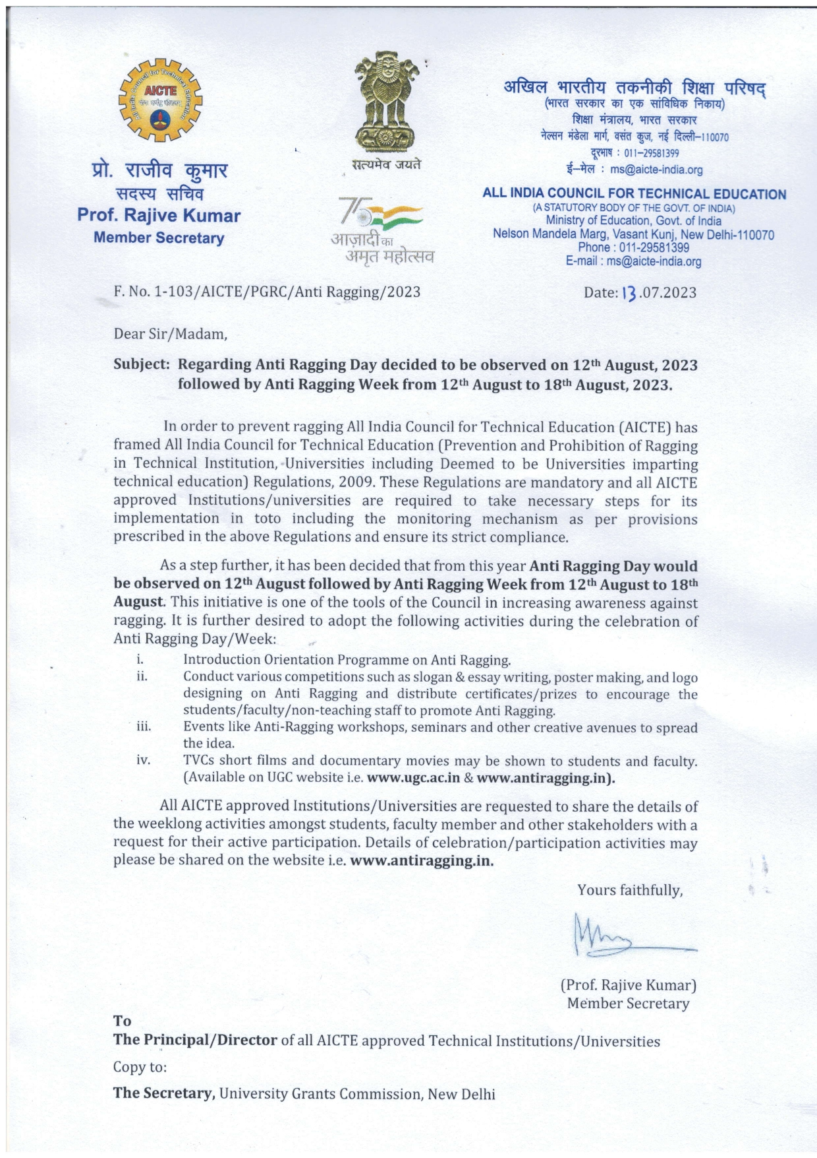

**Ragging Complaints Registration**

The students in distress due to ragging-related incidents can contact National Anti-Ragging Helpline **1800- 180-5522 (24x7 Toll Free)** or e-mail to **helpline@antiragging.in**. Or They may also contact UGC Monitoring Agency i.e. Centre for Youth (C4Y) at **antiragging@c4yindia.org** or **011-41619005** or **98180 44577** (only in case of emergency)

**Awareness collaterals**

**Posters** Download: *www.ugc.ac.in/pdfnews/4957638_poster-ragging.pdf*

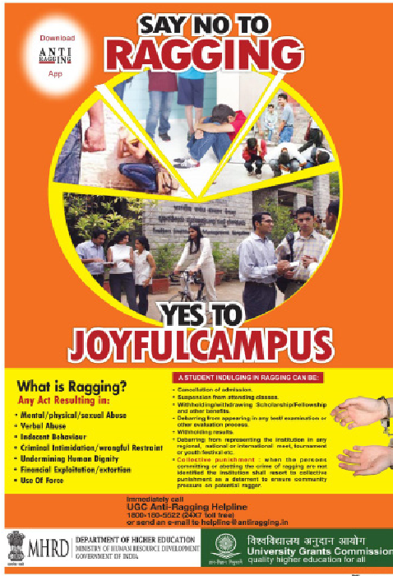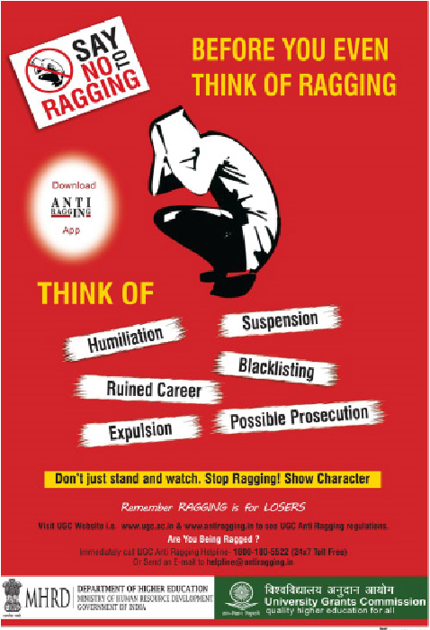

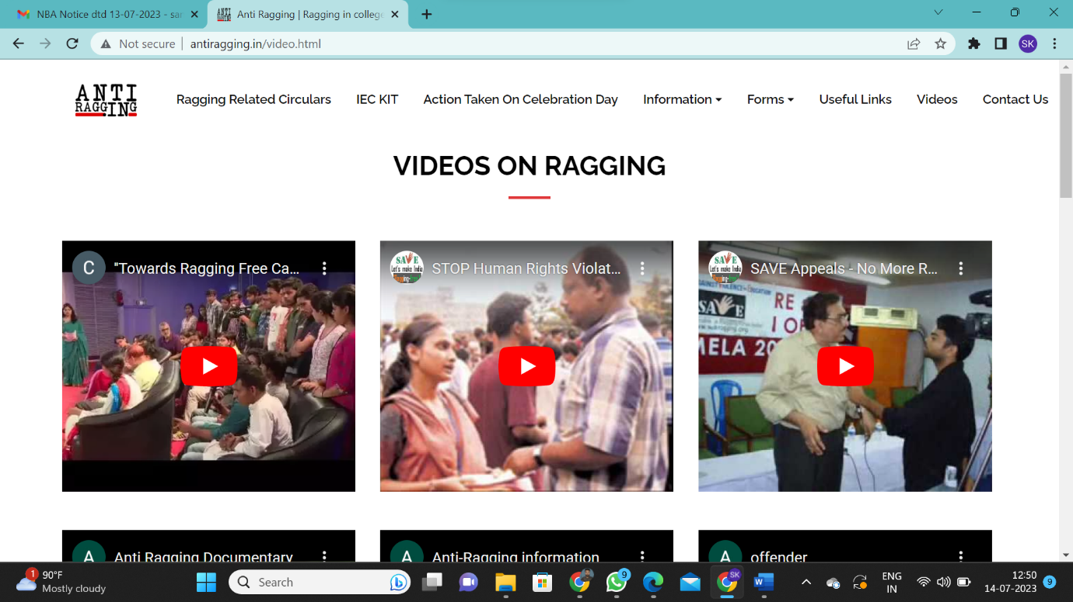

http://www.antiragging.in/video.html

**Videos**